Prologue
This workbook is designed to help you eat, shop, and live so that you not only lose weight, but keep off the weight. You can master this in six months if you give this workbook and program a serious effort. Each chapter breaks down a specific teaching point that you need for a healthy lifestyle. With focus and determination, you will be well on your way to winning this “weight loss” game for life.
For you who do not know me, I am Karen Hubacek, fifty-two year old mother of four, CPA, and owner of Right Weigh Clinic. How did I end up with a weight loss clinic, and why are people asking me for a workbook? The full story can be found on the Right Weigh Clinic website, but here is the abbreviated version. My fourth child weighed 103 lbs at seven years of age. I was trying everything but was unable to control her weight. She even swam on a year round swim team, played on two different soccer teams, two different basketball teams and a softball team. She also did gymnastics and ballet once a week.
I started attending American Society of Bariatric Physician conferences in search of anyone who could help me. Everything I have learned in 400 hours of conferences was in stark contrast to what my family was doing at home. And, for the record, we weren’t buying Lucky Charms and sodas. While our diet wasn’t excessively fattening, key aspects ultimately proved to be impeding our health and weight loss goals. Using what I learned during years of research, I altered our lifestyle to eliminate counterproductive ingredients found in almost every processed food.
After our family became healthier, people wanted to know how we won the “weight loss battle”. It eventually became the Right Weigh Clinic. I have sat through more than 400 hours of “weight loss” conferences and am still shocked at what the general public believes despite scientific evidence to the contrary.
Food sources have changed drastically over the past four decades while our metabolism has stayed the same. We metabolize food the way humans have for centuries. In the past, people either picked or killed food and ate it. Now, everything is altered before it reaches us. We have only been globally mass producing and processing grains and sugars for forty years, and the result has been a fifty-fold increase in Metabolic Syndrome (also known as Insulin Resistance or Pre-diabetes). When over-consumed, these very refined, white, starchy foods cause insulin resistance. Insulin Resistance causes excessive fat storage and can eventually lead to type 2 Diabetes. The CDC (Centers for Disease Control) estimates that by the year 2030, half of our country will have type 2 Diabetes. This statistic is over 60% for the state of Mississippi.
Diabetes is much more threatening epidemic than the “obesity epidemic” in our nation, and it develops when insulin can no longer work efficiently in the cells to control blood sugar. Put simply, sugar is a crystal in its microscopic form, so when these sugars are banging around arteries, they are scratching the delicate lining. This leaves scars and rough places that plaque easily attaches, which clogs the arteries.
These twelve lessons are designed to not only help you reach your ideal weight, but to help you lose real body fat and prevent type 2 diabetes. By educating yourself and following the guidelines presented, you will change your life forever.

“Success is not final, failure is not fatal: it is the courage to continue that counts.”
― Winston S. Churchill

Realistic Weight Loss Goals
Overweight vs. Obese
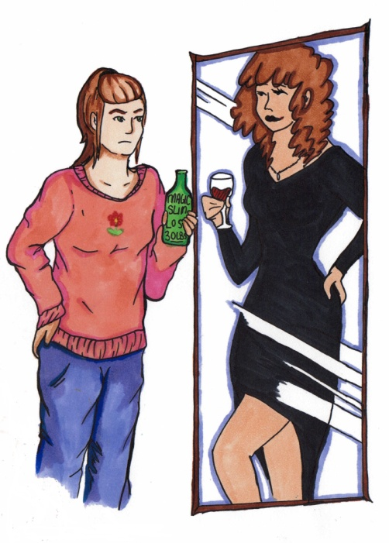
Some people are overweight, but many overweight people are also obese. What is the difference? By definition, overweight people have a Body Mass Index over 25 whereas obese people have a Body Mass Index over 30. But this definition is woefully inadequate. Anyone with a body fat percentage over 30% is at risk. Why is this important? Obesity is a chronic and progressive disease and should not be treated the same as just being “overweight”. There is no cure for obesity. Without continuous treatment, obese people will continue to gain weight and ultimately develop co-morbid conditions such as high blood pressure and type 2 diabetes. “Obesity” is not a personal failure or a lack of will power but a medical condition known as metabolic syndrome.
While diet and exercise can help most overweight people get to their ideal weight, this does not address the problems of the obese patient with metabolic syndrome. Many treatments are available to treat obesity including gastric bypass surgeries. However, the only “treatment” that has ever worked permanently in all the history of weight loss is real and permanent life style changes. Telling an obese person to “eat less” is much like telling a clinically depressed person to “cheer up”. It is not that simple.

Homeostatic weight gain haunts the obese patient because the body will constantly try to get back to its highest weight. This makes sustainable weight loss very difficult. Understanding the obstacles is important when making the decision to take control of your weight and life. Many patients are able to stop taking blood pressure, cholesterol and type 2 diabetes medicines after losing just 10% of their weight.
Obesity is not a personal failure, it is a real medical condition known as metabolic syndrome.

The 10% Rule
So what is “ideal weight” and what is a “realistic goal weight”? Good questions. You could ask 100 bariatricians and get 100 different answers. For a lot of people, your ideal weight is the weight you can sustain (and not gain weight) without having weight related diseases. Most patients are able to discontinue blood pressure and cholesterol medicine after losing just 10% of their weight when the weight loss comes from mostly body fat. It is very difficult to do this alone. When beginning a weight loss program, the first realistic goal weight should be 10% of your total weight and 10% of your body fat. At RWC, we focus on the percentage of body fat. It is our goal to get our patient’s percentage of body fat down to 30%. If you have less than 30% body fat, you literally eliminate the risk, due to weight, of acquiring all weight-related diseases including type 2 diabetes. There might be genetic or other environmental reasons you acquire them, but it will not be because of obesity.
●●●
Most people can achieve & sustain 10% weight loss in 16-20 weeks
●●●

We do this by weighing on a body mass analysis scale weekly. By weighing weekly, we are able to make timely changes to your program to help keep you losing body fat. Obviously, if it was easy, everyone would be walking around skinny. The proper medical, emotional and social support is absolutely necessary.
If all your weight loss is from “fat free mass”, it is rarely sustainable. You have less muscle to burn calories
At each weekly weigh-in, we will provide you with a copy of your body mass analysis. The BMA scale uses a very small current (it needs skin contact, this is why we remove shoes) to determine your body mass composition. You don’t feel the current and the scales are only accurate 3-5% but it still the best tool we have to ensure you are in fact losing body fat and not just muscle and water weight. The impedance number on the BMA is the rate that the current went through your body. This number needs to be within 25 points of other analyses in order to compare the analysis with another analysis. The fat free amount shows all your weight that was not body fat and this number includes muscles. Sometimes this number goes up when you start exercising and building muscle mass.

●●●
It is our goal at Right Weigh Clinic to help all our patients get their % of body fat closer to 30% for women and 20% for men
●●●

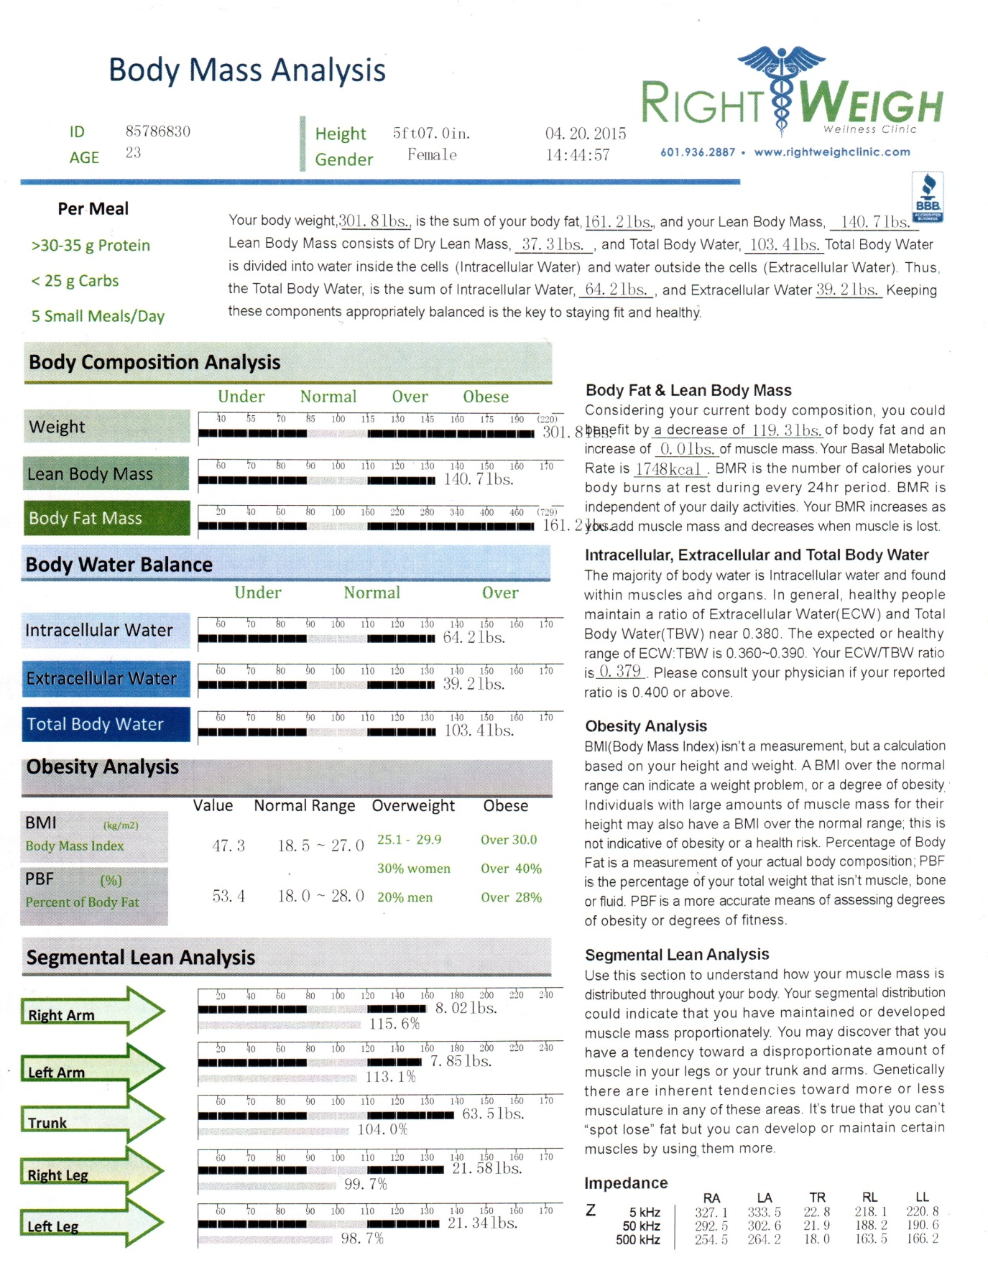

Environmental Obstacles
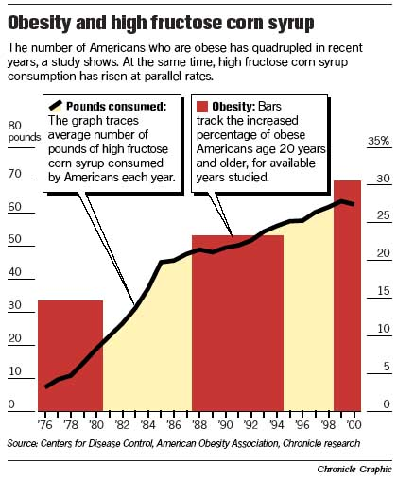
Obesity rates have steady increased since the mid 70s. In 1970 14% of Americans were classified as obese. Today over 35% of Americans are obese. In Mississippi these numbers are even higher. So why have so many Americans become overweight and obese? These following charts are from the Centers for Disease Control showing some correlations between obesity and environmental factors.
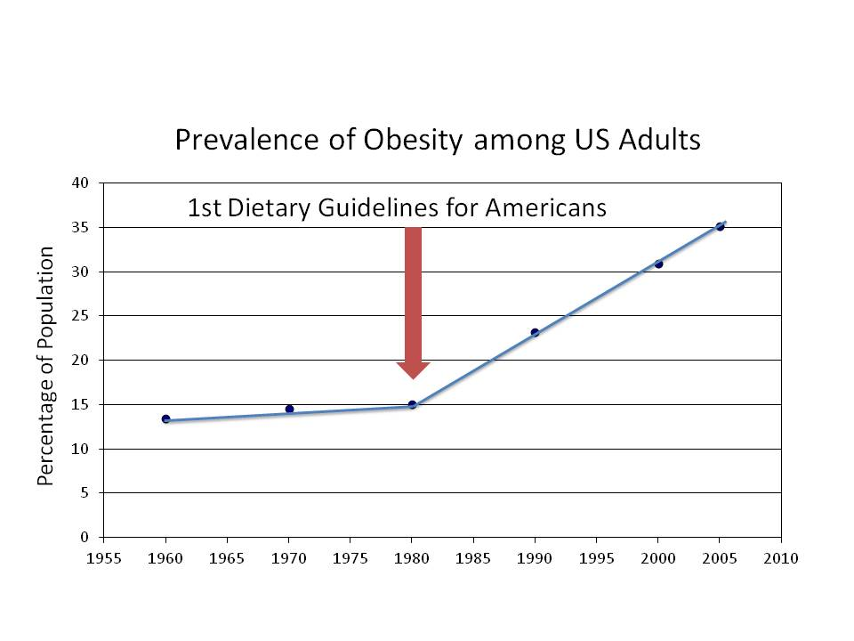
And while the “obesity trend” in America (and especially Mississippi) is alarming, even more alarming is the “type 2 diabetes trend”. The Centers for Disease Control estimates by the year 2030, over 40% of America will have type 2 diabetes. TYPE 2 DIABETES IS A PREVENTABLE DISEASE!!!! No one has to develop this painful disease.
In this graph, you can see how much Americans gained weight with the introduction of the food pyramid. The food pyramid taught us to restrict meat and eat 8-11 grains per day.
There are many factors that have contributed to the rise in obesity since the 1970s. So, what happened (or began to happen) in the 1970s to initiate this trend?
- People are a lot less physically active than people were in the 70s.
- We eat a lot more processed grains (such as bleached flour) than people did in the 70s.
- We do not have an understanding of how our bodies metabolize processed foods. We especially do not understand the consequences of over consuming them.
- As a society, we eat more of our meals outside the home (46%). We rarely prepare our own food anymore. A lot more calories are available to us in the form of fast food restaurants.
- The dietary guidelines were introduced in the late 70s. (Food pyramid)
- High Fructose Corn Syrup has replaced sugar in 99% of prepared foods.
- Most of the major food producers have merged into 5 massive corporations. These global food industry giants developed the “Cheap Food Model”.
- Most of the fruits, vegetables and grains we eat now have been genetically modified. They are larger and sweeter than those eaten historically.
- People consume more calories per day than in the 70s.
- The medical community by and large are still using outdated BMI charts and instructing patients to restrict calories and get more active. And while this is important, it is only the tip of the iceberg in treating the obese patient with metabolic syndrome.
Calories Taken In – Calories Used = Net Weight Gain/Loss
We have heard this equation our entire lives, but is it really as simple as that? When dealing with food, a calorie is a unit of energy regardless of its food source. If a bag of chips claims that a serving is 100 calories, then your body must burn 100 calorie units of energy to completely use that bag of chips. Anything that is not used is stored for later, which is called adipose (fat). A pound of body fat is equal to 3500 calories of unused energy. Ugh!
3500 calories = 1 lb. You would have to exercise off 500 calories per day for 7 days to lose 1 lb by exercising.

So, if you want to exercise off the excess weight, you need to burn 500 extra calories a day to lose one pound by the end of a week (7 days). Alternatively, if you want to lose weight by restricting calories, you can cut 500 calories a day from your diet and lose one pound at the end of seven days. The human body burns energy by being alive. Breathing, talking, walking, and even sleeping consumes energy, but most people eat far more than our body naturally burns just by doing our daily routine. This is precisely why it is essential to regulate not only our calorie intake but also our exercise.
●●●
Body fat loss results from maintaining muscle mass while restricting calories.
●●●

This is the reality of weight loss. It’s not what we want to hear, but it’s the truth. Any method that promises rapid weight loss without exercise and/or dieting is temporary and rarely sustainable. These types of plans are deceiving—they are usually water or muscle weight loss, not body fat loss. We see the number on the scale go down, so we think the diet is working. In reality, we are ruining our bodies’ metabolism. Muscles burn calories and water is essential for the body, so we really don’t want to lose our “weight” from these places.
Proper dieting revolves around protein consumption. Calorie-restricted diets need to include at least 30 grams of protein per meal (35 for men). Most women need to restrict calories to 1200-1500 calories per day and most men need to restrict calories to 1500-1800 per day. Don’t go below 1000-1100 calories per day. Doing so limits fat loss.
To maintain muscle mass while losing weight, you must get 30-35 grams of protein per meal, 10-15 grams of protein per snack in between meals and be exercising.
The General Guidelines:
- At least 30 grams of protein per meal for women, 35 per meal for men.
- No more than 25 grams of carbohydrates per meal
- No more than 550 calories per meal
- Approximately 20 grams of fiber per day
- No more than 2.5 grams (2500 mg) of sodium per day
- Eat 5 smaller meal per day to keep metabolism higher. Try to get 15 grams of protein in your in between meal snacks.
Right Weigh’s prescribed menu plan will make it very easy to stay within the calorie, protein, and carbohydrate restrictions. However, you are encouraged to count these for yourself using the diaries provided in this chapter. There are also templates available on the website. In this first chapter:

Basic Nutrition Facts
1 gram of protein = 4 calories
1 gram of fat = 9 calories
1 gram of carbohydrates = 4 calories

1 serving (30 grams) protein = 4 ounces or about the size of a deck of cards or the size of the palm of your hand.


1 serving of carbohydrates = ½ cup 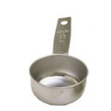or
about the size of a racquetball.

- Eating smaller meals more often keeps your metabolism higher.
- Do not skip breakfast. It is the most important meal of the day.
- There are 8 essential amino acids found in proteins that the body can not make, we must consume them.
- There are 2 essential fatty acids the body needs, Omega 3 and Omega 6
- Fiber, real fiber, chemically bonds to LDL cholesterol and we eliminate it.
- 12 teaspoons of sugar is the maximum we can metabolize each day without requiring a lot more exercise or storing it as fat tissue.
- The more hydrated you are, the higher your metabolism will be.
- Muscles burn 35 calories per pound per day. Body fat only burns 6 calories per pound per day.
Reading the Nutrition Facts Label
RWC Crock Pot Roast
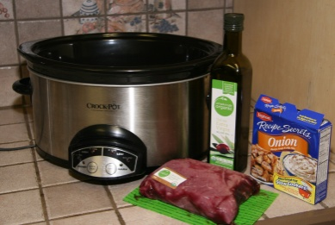
Ingredients:
- Pot Roast
- Olive Oil
- Lipton Onion Soup Mix:

Instructions: Pour just enough olive oil into the pot to cover the bottom. Place roast on top of olive oil. Sprinkle 1 packet of Lipton Onion Soup Mix over the roast. Add just enough water to cover roast. Cover and set time or temperature, depending on your crock pot. Usually 8 hours will get the roast cooked and tender.

Insulin Resistance

What’s A Carb?
If you are reading chapter two, then you must be serious about your health. Chapter one was serious and real but not what people want to hear. I am so glad you are not one of the thousands that want to just lose weight quickly and easily at the expense of your health. I created my whole program for you! There is no magic cure to lose weight. But with the proper medical support, anyone with the desire can lose weight and sustain the weight loss. This chapter is about insulin resistance. This is also the carbohydrate chapter. Ever since Dr. Atkins presented his no carb diet, this has been a source of controversy. What is a carb? Carb is short for carbohydrates and have been a staple in the human beings’ diets for 4000 years. A carbohydrate is technically a compound of sugars and other molecules. Carbs get broken down into glucose (simple sugar) by our bodies. Just about anything you can pick from the earth and eat contains carbohydrates and ultimately gets broken down into glucose (sugar) when we metabolize carbs. The “starchier” the food, the more carbs it usually contains.
If it grows out of the ground, it is a carbohydrate. Our bodies break all carbohydrates down into glucose. When it’s glucose, our bodies don’t know if it came from broccoli or a chocolate bar, it’s just sugar to the body
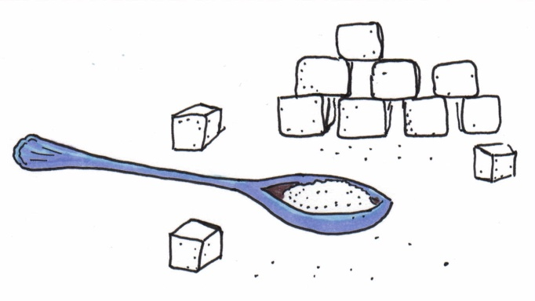
There are entire divisions of biochemistry that concentrate on carbohydrates, but for simplicity, I am going to leave most of the big science words to the scientists. Carbs are organic compounds that contain hydrogen, carbon and oxygen. How those elements are bonded determines if the carb is a monosaccharide, polysaccharide etc. All you need to know for weight loss is that once carbs are broken down into glucose, the body has no idea what food source you ate. Glucose looks the same to our bodies whether it came from broccoli or chocolate. This is important as you will see later.
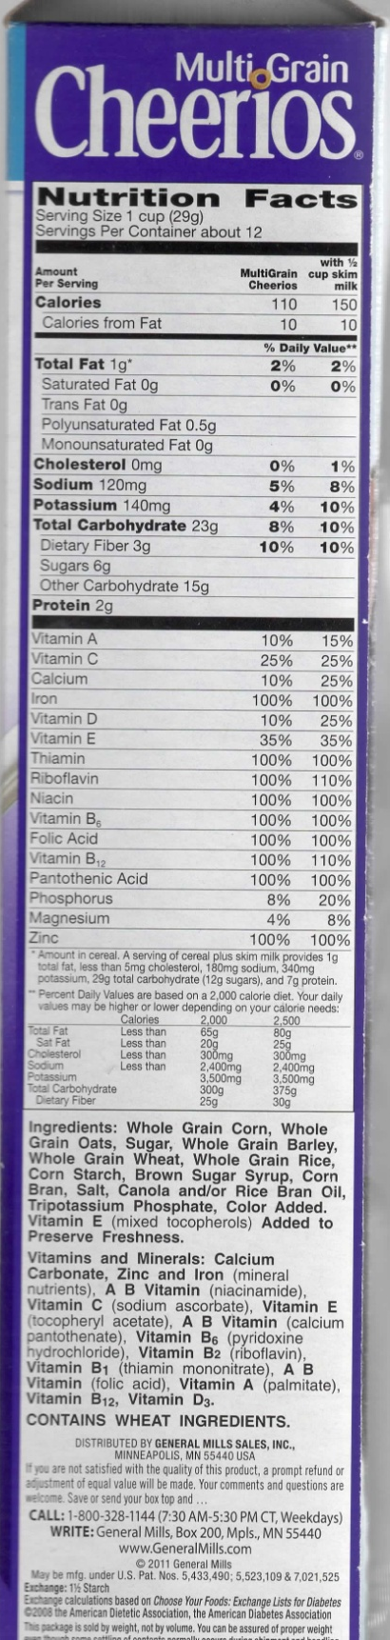
Think about the way people survived for the past 4000 years. Fruits ripen at the end of summer and most crops are harvested in the fall. People ate them and stored the carbs as body fat for energy during the leaner winter months that followed. They are perfectly designed to be stored as energy for later. How does the body store energy??? Body fat. I am not saying, “don’t eat them”, on the contrary. Vegetables, grains, nuts and fruits have lots of nutrients that our bodies use to build enzymes and genetic material and also help immune systems, fertilization and tissue development.
How many carbohydrates can we eat before we start storing energy (fat)? The scientific research varies between 6 teaspoons of sugar (Heart Association) and 12 teaspoons (Diabetes Association) per day. If you exercise a lot and burn a lot of additional calories every day, then you can eat more than 12 teaspoons of sugar and not store it as fat. That is because it will be used for energy by your vigorous activity. I know what you are probably thinking. How in the world can I possibly know how many teaspoons of sugar I am eating when all I have to use is a nutrition label on the side of the box? Here is a simple way to convert grams of carbs into the teaspoons of sugar it will ultimately become in your body.

Total Carbohydrates – Fiber Carbohydrates = Net Carbohydrates
Net Carbohydrates ÷ 5 = Teaspoons of Sugar
Thank you Dr. Rader for this very simple explanation!
You can see why it doesn’t matter where your body got the glucose (sugar) for weight control, it matters how much your body is getting.
Now let’s apply that to a real life situation. We have just poured ourselves a bowl of cereal. The Cheerios box proudly shows that a serving only contains 110 calories. Keep in mind that 1 serving is 1 cup. That is about the volume of a tennis ball. Ugh!
Wait!! Let’s see if this tiny little bowl of cereal has 30 grams of protein. No, it only has 2 grams of protein. We will add about 7 more grams of protein when we add our milk but we are still short. A 70 calorie protein shake will get us up to 30 grams of protein (for muscle mass maintenance, more on that in the next chapter ). Let’s keep looking.
Let’s see how many teaspoons of sugar we are really eating for breakfast. The nutrition label says 23 g of carbohydrates. Remember our formula for converting to teaspoons of sugar.
- Subtract the 3 fiber carbs which nets us 20 grams of carbs, well within our 25 gram limit.
- 20 net carbs ÷ 5 = 4 teaspoons of sugar of the 12 teaspoons of sugar we can efficiently consume in an entire day.
This only leaves us 8 teaspoons of sugar we can eat unless we are willing to use it by exercising or store it as fat. Ugh!

Compounding this fat storage problem even more is the fact that these carbs are very processed. Whole grains are better than bleached flour but they still break down very quickly into glucose. In fact, some of the processed grains like bleached and enriched flour are completely broken down into sugar by our saliva!
Processed carbs (if it’s in a bag in a box, that’s a good indication it is processed) cause insulin spikes in the blood stream because insulin is the hormone that keeps blood sugar under 100 mg/dL. When our eyes see that bowl, our ears hear the cheerios hitting the bowl and our nose smells them, our pancreas starts secreting insulin.
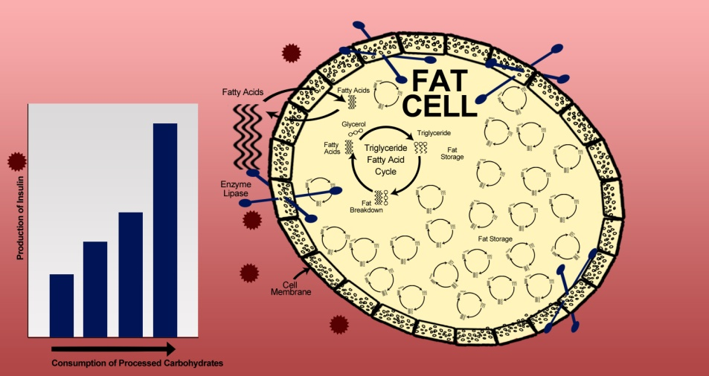
Insulin is secreted by the pancreas and tells the enzyme lipase to grab free floating blood glucose (sugar) and pull it into the fat cells and bind it a glycerol so that it is too big to get back out into the blood stream. This illustration adapted from Gary Taubes’ book, Why We Get Fat shows how insulin controls blood sugar by storing it as fat in the fat cells.
Over time, the fat cells become resistant to the insulin demands. Eventually the fat cell gets too full of triglycerides and breaks them down anyway. The sugar (in the form of fatty acids here) s gets released into the blood stream. When the pancreas detects this additional blood sugar, it makes more and more insulin to control blood sugar and send it back into the fat cells. Over time you require more insulin to control blood sugar.
When you are storing more than 30% of your weight as body fat, then you should be concerned that you are insulin resistant. Over 85% of overweight Americans have insulin resistance.
Let’s apply the “teaspoons of sugar” test to a healthy food that isn’t processed. Here is a typical banana. While rich in fiber and potassium, a typical banana will ultimately be broken down into 9 teaspoons of sugar. The math:
- 51 grams of carbs – 6 grams of fiber = 45 net carbs
- 45 net carbs ÷ 5 = 9 teaspoons of sugar
It is very difficult to lose body fat if bananas are part of your diet. One banana only leaves 3 more teaspoons of sugar we can eat before we start storing them as fat or exercising them away.
I’m not saying not to eat fruits, vegetables, nuts etc. I just want you to understand how to eat them as part of a calorie restricted diet to lose weight. Yeah, just don’t eat bananas. But if you do eat fruit, do the math and calculate how much sugar you are eating.
Typically a ½ cup is a serving size of a fruit or vegetable. That is about the volume of a racket ball.
The good news is that fruits and vegetables are not processed and it takes the body longer to break them down into glucose. So they do not cause the insulin spikes that processed carbs cause.
Non Alcoholic Fatty Liver Disease (NAFLD)
There are other ingredients that are contributing to the alarming number of Americans with Insulin Resistance. A very common one is High Fructose Corn Syrup (HFCS). Fructose is the sugar that occurs naturally in fruits and vegetables. That is how the manufacturers make it from corn. But since the late 70s, HFCS has slowly replaced table sugar as the sweetener in 99% of processed foods. If you remember the early 80s when Coke when to New Coke? The cost went from $2.49/6pk to $3.89/6pk overnight at my Kroger. HFCS is much cheaper to use in manufacturing than sugar.
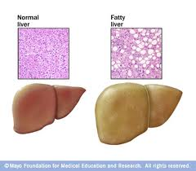
Here are some stone cold sobering facts about this sweetener. Back in the early 70s, people consumed about 7-10 grams a day of fructose and all from real fruits and vegetables. We would have to use our own metabolic energy to rip and tear away at the food to get to the fructose to metabolize it. Today’s average American consumes more than 100 grams of fructose a day and all from this product. Manufacturers have added it to almost every food item. Human beings were never meant to metabolize this much fructose. In fact, you could not probably consume 100 grams of fructose in nature. You would stand under an apple tree and burst from eating apples before you’d consume 100 grams of fructose!!!
Our liver has to metabolize the fructose (in the same pathway that we metabolize alcohol). What has happened since the mid 70s is livers are storing more and more of the excess fructose as fat INSIDE THE LIVER. In fact, Non Alcoholic Fatty Liver Disease was the most increased diagnosis in our country last year. The National Health Institute estimates as many as 78% of Americans have some level of excessive fat storage in the liver.
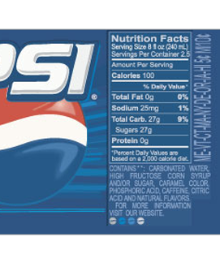
Why is the relative to weight control? Fatty liver contributes to insulin resistance which leads to excessive fat storage.
To know if you are consuming HFCS, look at the “Listed Ingredients” on the nutrition label. Most sodas list HFCS as the second most abundant ingredient in the can.
I challenge you this week to go through everything in your pantry and examine the nutrition label. If it contains bleached or enriched flour or high fructose corn syrup, get rid of it.
Looking at this label also shows this one can of soda contains over 5 teaspoons of sugar.

Type 2 Diabetes
Many lifestyle changes have occurred over the past 4 decades. The over consumption of processed carbs combined with decreased physical activity have largely contributed to the type 2 diabetes epidemic in America and across the globe. The truth is very alarming. The obesity epidemic is a symptom of a much larger and more severe epidemic sweeping our nation. The Centers for Disease Control estimates half our nation will suffer from type 2 diabetes in just a couple decades. In Mississippi, the CDC estimates over 60% of our adult population will have type 2 diabetes by the year 2030.
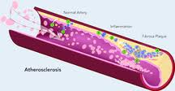
Any person with over 30% body fat and a waist circumference over 35 inches (40 inches for men) is at risk for insulin resistance and developing type 2 diabetes. Type 2 diabetes occurs when the body can no longer use insulin efficiently to shuttle glucose out of the blood stream. Sugar is a crystal. Even its molecular form, it is still a crystal. So when these sharp molecules of glucose are allowed to flow through our arteries, they are bumping the delicate lining of the arteries and scarring them. This scarred tissue makes it easier for plaque to accumulate.
The tiniest arteries are capillaries. These are at risk of becoming completed blocked due to scarred to the point that blood can no longer circulate bringing vital oxygen and nutrients. This is why diabetics often have to have kidney dialysis. The kidney arteries are so small; it makes the kidney very vulnerable to this disease. Another organ that is very vulnerable is the eye. The retina has very small arteries so it takes less scarring to completely block circulation to the eye.
THE GOOD NEWS is the type 2 diabetes is preventable. This workbook is as much designed to help you prevent type 2 diabetes as it is designed to help you obtain and maintain a healthy weight.
Remember our first weight loss goal is to lose 10% of total weight and 10% of body fat. This will make insulin work more efficiently. Exercise is a powerful way to improve insulin efficiency as well. So, focus on how much healthier you will be at the end of this journey. There to no cure for obesity so you have to commit to this lifestyle and focus on the fact that you will not be one of the 100 million people that will require insulin pumps and kidney dialysis to live.

Chapter 3 Get Moving!

Goals for Chapter 3:
- Learn all the benefits you get from regular exercise.
- See how exercise helps maintain muscle mass and forces the body to burn body fat when you restrict your calories and consume enough protein.
- Find an aerobic exercise that is fun for you.
- Strength or resistance training helps you maintain muscle mass. Don’t underestimate the benefits of strength training.
- Write down at least 3 ways to incorporate more activity into your daily lifestyle.
- Keep the food and exercise diary for 7 days.

Get Moving
Suppose that I offered you a pill available for $5 a day that would extend your life expectancy by 3 to 7 years. Would you buy it? Would you if I told you that it also controls weight, lowers HDL (bad) cholesterol and triglycerides? That’s worth $35 a week, don’t you think?
Well, that’s not all this little pill does. It lowers your risk of vascular disease, which lowers your risk of having strokes. For only $5 a day, you can avoid developing metabolic syndrome and type 2 diabetes. This magic, amazing pill also prevents some cancers and relieves arthritis pain. It helps you avoid falling and improves balance. Now $5 a day is sounding like a steal. But wait, there’s still more! This fantastic, all-natural pill also improves moods by stimulating certain brain chemicals which not only make you happier but make you more relaxed, reducing the risk of depression. Does it sound impossible? It is true, and there are decades of research to support these medical claims. Well, that’s still not all this little pill can do! It gives you more energy and endurance, helps you sleep well at night, and improves your sex life! All of this and more for less than $2000 per year!
What if I told you that this pill is available free of charge? I bet that now you’re starting to get the idea; this magic pill isn’t a pill at all. It is, in fact, exercising a mere thirty minutes a day. Proper exercise is absolutely essential to keeping yourself healthy. It’s inexpensive and it actually accomplishes everything that a “magic” little solution might promise.

Exercising Results in Body Fat Loss, Not Just Weight Loss

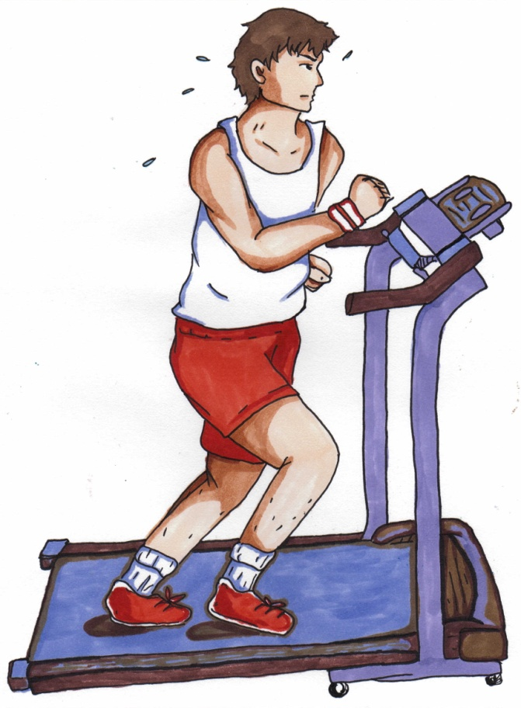
Exercising forces the body to burn off body fat when you restrict calories to lose weight. There is a big difference between losing “weight” and losing “body fat”. Most people lose weight when they go on a diet. However, if the weight you’ve lost has come mostly from muscle mass or water weight, then you are left with fewer muscles with which your body can burn calories.
When you restrict calories to lose weight while failing to exercise or build muscle mass, your body will break down your muscles to use the proteins to build hormones, enzymes, blood cells, etc. It is easier for the body to break down muscle cells than to break down fat cells, and that is exactly what it will do if you restrict calories without getting enough protein and exercise.
Evidence shows that when the body does break down muscles, it also alters your metabolism to require fewer calories. If you begin to consume more calories after muscle loss, you will gain the weight back even faster because you don’t burn as many calories doing the exact same things as you did before the diet.

Exercise Programs
There are several ways to get started on a cardio exercise program, but here are a few recommended by the American Society of Bariatric Physicians for weight loss:
- Walking programs—walk briskly for 45 minutes. You should not be able to carry on a conversation if you are walking briskly enough. You should be panting, but not dizzy.
- Jogging/Running programs—jogging 12 minute/miles for 30 minutes will burn about 275 calories.
- Zumba classes—these are taught in classes at gyms and churches but are also available on DVD. Janelle teaches them for $3/class. Class times are on the Pearl Parks and Rec website.
- Spin classes—spin classes are intense, teacher-led classes that really get your heart rate up and your body burning calories.
- Bicycling—bicycling for 30 minutes can burn 300 calories.
- Stair climbing—by either climbing real stairs or using a stair-climber machine, you can burn off over 200 calories in 30 minutes.
- Swimming—30 minutes of swimming laps at a moderate speed will burn around 300 calories.
*These numbers were figured for an average, 150 lb person

Strength or Resistance Training
When doing strength and resistance training, your form is very important. Some good websites that illustrate form are www.emedicinehealth.com/strength_training and http://health.usnews.com/health-news/diet-fitness/articles/2009/04/10/10-forms-of-resistance-training-that-strengthens-your-muscles
- Wrist/Ankle Weights
- You can wear 1 lb ankle or wrist weights and do exactly what you would every day.
- Squats
- Squats are one of the biggest “bang-for-your-buck” strength training exercises. They use several muscle groups and burn a lot of calories. To do a squat properly, stand with your feet hip-width apart, toes forward, and slowly bend your knees and lower hip toward the floor. Keep your torso straight and pulled tight. Don’t go lower than 90 degrees. Do 12-16 proper squats a day.
- Lunges
- Lunges are a great way to build strength and stretch muscles. To do a lunge properly, put one foot ahead of you on the floor. Lean forward onto that leg while keeping the back foot planted solid on the ground. Hold for 8 seconds. Switch legs and repeat this 12-16 times.
- Flexible bands
- Flexible bands have many of the fitness benefits of free weights without the cumbersome heavy equipment. This is a low cost way to exercise many of the body’s muscles. Fitnessbliss.com has 40 different workouts using flexible bands.
- Exercise ball
- Exercise balls exercise core muscles. The ball can be used as a chair for people with desk jobs which can tone core muscles throughout the day. Sitting on one during a one hour television program can strengthen core muscles.
- Exercise videos and DVDs
- These vary a lot so find one that looks to fun to you. Ask the physician if you are concerned about your ability to use them.
- Free weights
- Free weights allow you to work on very specific muscle groups. There are lots of websites that demonstrate the benefits of using free weights such as muscleandstrength.com
- Push ups
- Push-ups are another good “bang-for-your-buck” strength training. Beginners should start by placing his or her hands on a counter and doing the push-ups from that height and slowly, over time, working down to the floor by choosing lower and lower surfaces to use.
- Abdominal Crunches
- Crunches, when done properly, burn a lot of calories and tone the stomach area. Strengthening core stomach muscles often results in less back pain for people who suffer from chronic back pain.

Exercise can be fun!

Pick something that you have always wanted to do, such as ballroom dancing or hiking with your friends and family. Some of my patients want to finish 5ks that support an organization that was important to them such as cancer awareness or diabetes prevention. There are several apps for your smart phone that allow you to not only train and track your training but also provide an easy way to challenge yourself and others. Nike+GPS is my favorite one of those apps. I challenged my sister to see who could complete the most kilometers in one month, and to this day that is the most kilometers I have ever jogged in a month!
Make Exercise a Part of Your Daily Lifestyle
-Enlist a friend, spouse or family member.
-Write down your realistic goals and keep an exercise journal. Make very specific goals. Instead of writing “go walking”, write “walk for 30 minutes”. Instead of writing “ride bicycle three times this week”, write “ride bicycle for 10 miles on Monday, Wednesday, and Saturday”.

-Incorporate exercise into your chores and work place.
-Give your spouse a workout
-Park further away from your destination to add steps to your journey.
-Take the stairs
-Set your smart phone to remind you every hour to get up and do 5 squats or 10 jumping jacks or anything that increases your metabolism.

-Pick one day of the week to be family night. Several of my patients are playing Xbox Kinect and Wii with their children on certain nights of the week and they are really enjoying not only the exercise but also the bonding time with their children.

Write in below how you plan to incorporate more activity into your daily life:

-

-

-

How Protein Works with Exercise to Cause Real Body Fat Loss
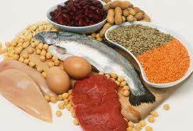
Everything in our bodies is made from amino acids we get from protein. We get proteins from the foods we eat. Our bodies cannot make 8 of the essential amino acids, so it is imperative that we get them in our diet.
We use amino acids to build hormones, enzymes, blood cells, muscles, bones, skin etc. Most people need about 20 grams of protein per meal to maintain their current muscle mass. Our muscles serve as this great big reservoir of proteins for our bodies. When food is scarce, the body uses these muscle cells’ proteins to build vital hormones, blood cells etc. When this happens, our bodies go into sort of a “survival” mode. The body hangs onto fat cells because it thinks food must be scarce, otherwise we’d be eating protein.
Remember, people are still hard wired for survival the way people have eaten for 5 thousand years. People picked their food or they killed their food. All of these types of foods contain protein. If you restrict your calories to lose weight and do not consume enough protein to maintain muscle mass, then your body will break down muscle for proteins. It is actually easier for the body to use muscle tissue for energy than it is to break down a fat cell for energy.
So we are back to 3500 calories = 1 lb. It isn’t realistic to think that you will hit the gym and exercise off 30 pounds. 30 pounds would require 105,000 calories burned. But it is absolutely essential for body fat loss that you be using your muscles and putting serious demands on them. Using the muscles and feeding the muscles proper proteins, forces the body to break down body fat when you restrict calories to lose weight.
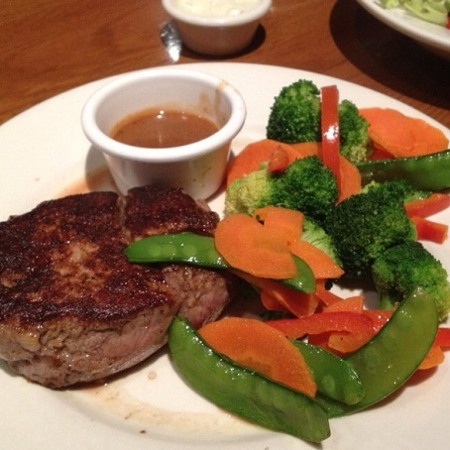
Restaurant Pick of the Week
Outback Steakhouse 6 ounce filet with steamed vegetables
This meal contains more than the 40 grams of protein, 10 grams more than required to stay on the RWC lifestyle. The fillet with steamed vegetables also limits carbs to only 11 grams (well within our 25 gram limit). These are complex carbs too so they will not spike insulin levels. Total calories for this meal are only 351. You could even add a grilled shrimp appetizer for only 150 more calories and 14 grams of protein. It would be best to share the appetizer with someone or bring half of it home for later.
Avoid the bread as 1 serving has more than 70 grams of carbs. Ugh!
Also, avoid all sweetened drinks. You might prefer to add an adult beverage instead of an appetizer?

RWC Crock Pot Bison Stew


Ingredients:
2 lbs cooked, ground bison (can substitute beef)
2 bags frozen soup vegetables
1 carton of low salt beef broth

1 tablespoon of Italian seasonings
1 teaspoon of cumin, cayenne, thyme and salt
1 can of diced tomatoes
1 can pinto beans
1 can of ale (optional)
Directions: Cook the ground bison in a skillet. Put all ingredients into the crock pot. Add 2 cups of water. Set crock pot for 6-8 hours. Add can of ale 1 hour before serving, if desired.
Serves 8. Each serving has 370 calories, 30 grams of protein, 22 grams of carbs and 3 grams of fiber.

Chapter 4 Help!

Goals for Chapter 4:
- Redouble your efforts since this is the time many people fall back into old routines.
- Consider all the medical support available and determine if one is right for you.
- Review your emotional support team and write down 3 reasons you want to change your lifestyle.
  - Reason #1
  - Reason #2
  - Reason #3

- Write down at least 3 social situations that tend to temp you off course and write down how you are going to overcome those situations in the future.
Social Situation #1
Solution:

Social Situation #2
Solution:

Social Situation #3
Solution:

- Stay focused on the long term goals. How close are you to your 10% weight loss goal?
- Keep the food and exercise diary for 7 days.

CHAPTER 4

Help!!!

We’ve only been in this for 4 weeks now, but it’s the time that a lot of my patients start getting discouraged. The “newness” has worn off and even though they are steadily losing body fat, the net weight hasn’t gone down as much as other weight loss programs promise. Many of us tend to start falling back into old routines.
So, let’s talk about the help available to stay committed and redouble your efforts when you get discouraged. Oh, I could say all kind of stuff like “focus on the health benefits” or “this is how you get to add calories back to your diet once you achieve your goal weight…”, but you guys don’t want to hear that. You want to see more net results because that is what all the diet scams we’ve had shoved into our brains our entire lives has us believing.
Don’t try to do this alone unless you live alone. My patients who make the lifestyle changes and get their entire families to do so have the most success. Of course the children whine when they realize that you are in fact not going to buy any more sugary cereal, toaster pastries or doughnuts for breakfast. They really bawl when they realize you are serious about not wasting time and money on fast food too. But you are doing this because you love them!!!
There are basically 3 types of help available when the new lifestyle gets to feel like it’s too hard:
- Medical support is available in the form of appetite suppressants, metabolic boosters, physician exams, nutritional supplements and weekly weigh-ins.
- Emotional support is available from friends, family, co-workers and partners.
- Social support is when you surround yourself with positive, encouraging people that help keep you on target.
First and foremost, do not hesitate to ask for help if you are feeling weak. If this was easy, everyone would be walking around fit and thin. The temptations are all around us, tempting us, counting on us to give in and go with the flow….. Constantly remind yourself that the old road eventually leads to type 2 diabetes, high blood pressure etc…and you are going to stay on this new road to a healthier, happier you.

Medical Support
- Physician exams are an important part of staying on a program. Not only can the physician prescribe appetite suppressants, but also identify other medical conditions that may be contributing to weight gain. The doctor can also identify conditions that are the result of being overweight. Thyroid disorders, adrenal disorders and fatty liver all contribute to obesity. High blood pressure, cholesterol and triglycerides are some of the conditions caused by obesity. It is also very important to have a physician look at your EKG and exam your joints before starting an exercise program, especially if you have been inactive for several years.

- Appetite Suppressants are a useful tool to use in the weight loss journey. But that is all they are, a tool. They are not a weight loss program by themselves. Appetite suppressants will sometimes decrease your entire appetite and you will forget to eat. So, they must be used in conjunction with an overall program that includes getting plenty of protein to maintain muscle mass, exercising to not only maintain but build muscle mass and limiting calories.

The most common prescription appetite suppressants are phentermine and tenuate. The FDA recently approved Qysmia and Belviq, but since they are new, they are very expensive. Very few insurance companies will cover weight loss so these expenses are usually all out of pocket expenses for patients.

Appetite suppressant side effects include; increased blood pressure and pulse rate, heart palpitations, dehydration, constipation, dry mouth, dizziness, insomnia, tremor, headaches and interactions with other medicines such as SSRI antidepressants. Phentermine has been around for over 50 years and (when screened properly) no one has ever died or become addicted to phentermine. However, it is a controlled substance for a reason! It is very important to come in weekly and have your blood pressure checked while using phentermine.

- Weekly weigh-ins help keep you on the program. It is very motivating to come in and see your body fat go down even if your net weight didn’t decrease. Also, our team of bariatric trained nurses, medical assistants and staff can access your progress and make changes timely to keep you losing body fat each week.

- Supplements can also make the weight loss journey a little easier or more effective. At Right Weigh, we have nutritional supplements that help burn body fat if you are exercising daily. These supplements are available in both tablet form and injection form. Other supplements we offer help increase metabolism such as, adenosine monophosphate (AMP). AMP has been used for decades to help people with autoimmune diseases such as chronic fatigue and fibromyalgia. While it is not a FDA approved “drug”, it is very helpful in making you feel like getting up and exercising. Because AMP is a naturally occurring molecule in the body, it can’t be patented by the drug companies so they don’t make AMP. We have ours compounded at a pharmacy in Louisiana.
Emotional Support
I am constantly shocked by the adverse forces in my patients’ lives! Married patients’ spouses/partners are often threatened by the changes that occur when they start getting control of their health/weight.
I have several female patients whose very overweight husbands constantly bring home foods that they know she loves and are certain to cause weight gain. They order pizzas, buy sodas and desserts, and every kind of chip product sold in a bag! Even though one of them has high blood pressure through the roof and is taking cholesterol medicine! Even when she has a healthy meal waiting in the crock pot and her husband still goes by a fast food restaurant on his way home. He even goes so far as to tell her that she’s lost too much weight and doesn’t look attractive anymore!
They constantly amazed me with their persistence to stay on course to obtain and maintain a healthy weight. When I ask one lady how she stays on course (and yes, sometimes she lapses) she says, “My children. I want them to learn how to eat to avoid health consequences. I know my children are watching and I want them to see that commitment to something right, leads to positive lifelong results.” Or something like that...
The point is there are always adverse forces working against your new lifestyle. But the forces within your personal relationships seem to be the most effective at derailing you. Grandmothers will be genuinely hurt when you don’t eat the apple pie. Sisters will be jealous when they realize you are in control of your weight and health. Children will whine when they don’t get to eat the same delicious looking garbage marketed to them that their friends get to eat. Boyfriends/girlfriends will want out to go out on dates to restaurants. And sadly, there are people you love that will maliciously try to sabotage your efforts because of jealousy, insecurity, fear of change etc.
You have to be a leader and not a follower. You have a tremendous opportunity to be a role model for all of the people you love. Stay the course! Human nature will make you want to cave in to their demands, but they will respect and love you even more when you are successful.
Look hard at all the people you love. If there is even one that wants to live a healthier lifestyle, then focus of that person. Share recipes and exercise tips. Find that person who will keep encouraging you and genuinely shares in the joy of your success. That person will say “great! Another pound of body fat gone!” instead of “Only a pound?” If you don’t have that person, then call me. I’ll tell you!

Social Support
OK, while you don’t have a lot of control over who is in your family, you do have a lot of control over most social situations. The most common social situation that derails my patients is co-workers. Either they all go somewhere for lunch or they all meet after work for dinner and/or drinks.
Dating, eating out, parties, and believe it or not churches all pose weight control challenges. If you start dating, then pay close attention to the Eating Out chapter of this workbook! Any place (especially churches and cafeterias) where they are feeding a lot of people, look for the cheap foods and avoid them.
I was at a funeral recently and nearly every choice on the table was a processed carbohydrate! I could not believe what I was seeing. Then I saw the people in line and nearly every single one of them was overweight. We call most processed carbohydrate foods “comfort foods” (casseroles, breads, pastas…) for a reason. A lot of them raise the serotonin levels in our brain just like antidepressants do. They break down into sugar very quickly and give us a little “pick-me-up” when our blood sugar goes up temporarily. But they do this at a great cost as they contribute each time to insulin resistance.
The point is, take control of your social situations. If you know from experience that your choices will be processed carbs, then eat ahead of time or keep protein snacks with you. There are lean protein options at nearly every restaurant, you just have to be strong and not snack on the bread or chips that the restaurant hopes fills you up before the meal.

STAY FOCUSED ON YOUR LONG TERM GOALS OF NOT ONLY BEING A HEALTHY, SUSTAINABLE WEIGHT BUT ALSO HAVING MORE ENERGY AND A MUCH BETTER QUALITY OF LIFE!!!!
Breakfast sandwich

Ingredients
2 slices of whole wheat English muffins
4 slices 97% fat free ham (rectangular, 30 cal/slice) or 5 slices of Jennie-O Turkey Bacon
1 slice light cheese (any variety, ex. Swiss)
1/2 cup EggBeaters or 4 cooked egg whites
Sliced red and green bell peppers lightly sautéed
½ cup sliced avocado

Cooking Instructions
In a paper bowl, add the EggBeaters and cook for 2-2 1/2 minutes on high until the egg becomes patty. Or cook the eggs in a pan lightly sprayed with Pam. On one piece of toast place the ham slice on top, followed by the cheese. Place the egg patty on top with the other slice of toast. Enjoy! Add hot sauce if desired.

Restaurant Pick of the Week

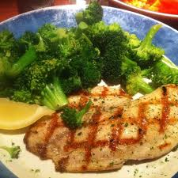
Red Lobster’s Grilled Fresh Tilapia served with fresh broccoli and a garden salad (blueberry balsamic vinaigrette on the side) is an OK choice if you find yourself dining out. To order this dish and stay within the Right Weigh Clinic guidelines of 30 grams of protein, 25 grams of carbs and total calories under 500, tell your waiter NOT to bring ANY biscuits with your meal.
This dish contains 34 grams of lean protein and only 26 net carbs. You will stay under the 500 total calories by avoiding the biscuits. The nutritional information provided by Red Lobster shows this menu item containing 410 calories as served. But remember, biscuits ultimately break down to sugar (glucose) and that makes it difficult to control appetite later. So, cut the biscuits and the associated calories. As always, drink unsweetened tea or water. Do not add an artificially sweetened beverage.

